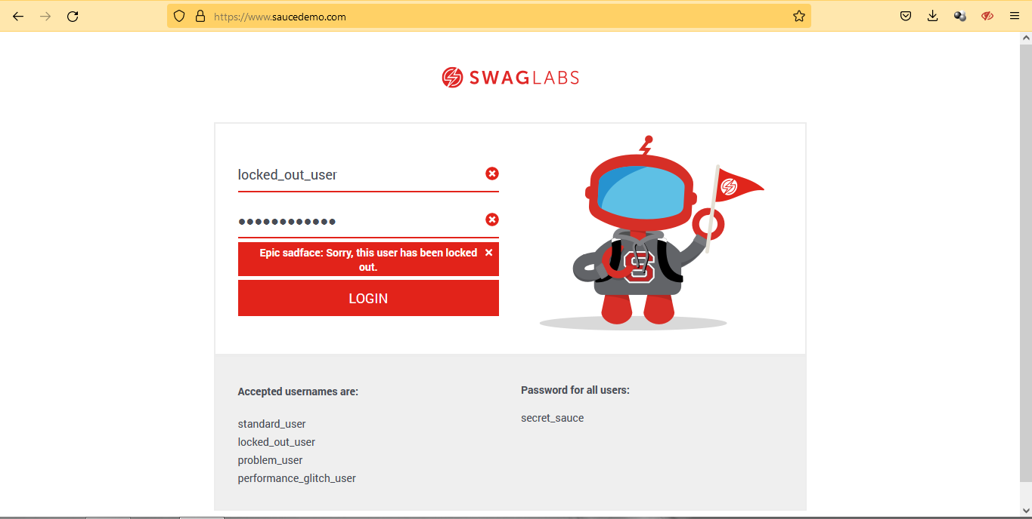

**[saucedemo.com][Web][Prelogin] the user has been locked out**

The issue occurs on Prelogin.

* User Open saucedemo.com
* Input username (locked_out_user) and password
* Notice that the user has been locked out

**Note:**  
Tested using Firefox 104.0.1 (64-bit)  
Repro Rate 100%

It's should the user can login.

Please see attachement for details.

Severity : Medium  
Priority : Middle  
Label : Web, Firefox  
Reporter : Aditia Angga Perdana  
Assigne : Dev

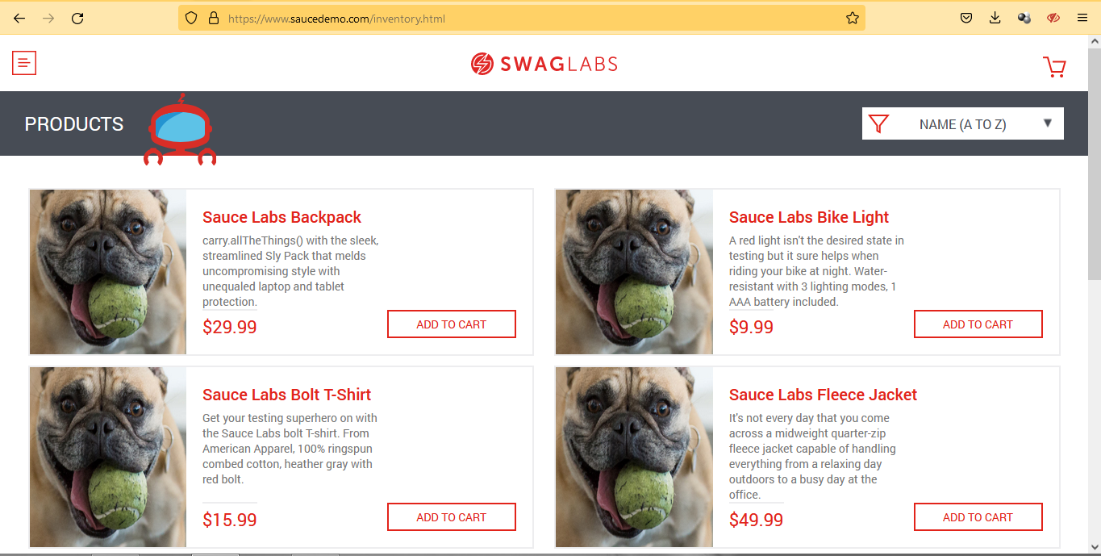

**[saucedemo.com][Web][Products] the images of each catalog is not match**

The issue occurs on Prelogin.

* User Open saucedemo.com
* Input username and password, after that click login
* Notice that the images of each catalog is not match

**Note:**  
Tested using Firefox 104.0.1 (64-bit)  
Repro Rate 100%

It's should the user can login.

Please see attachement for details.

Severity : Mayor  
Priority : High  
Label : Web, Firefox  
Reporter : Aditia Angga Perdana  
Assigne : Dev

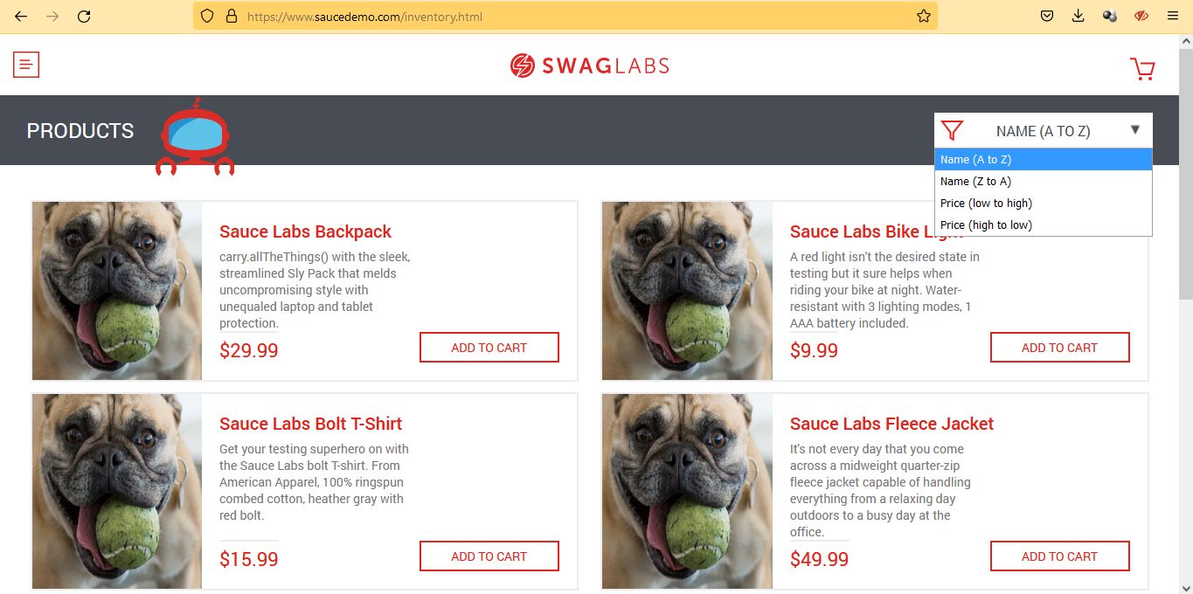

**[saucedemo.com][Web][Products][Sort] the catalog cannot be sorted**

The issue occurs on Prelogin.

* User Open saucedemo.com
* Input username and password, after that click login
* Click Sort, and choose every option
* Notice that the catalog cannot be sorted

**Note:**  
Tested using Firefox 104.0.1 (64-bit)  
Repro Rate 100%

It's should the user can login.

Please see attachement for details.

Severity : Mayor  
Priority : High  
Label : Web, Firefox  
Reporter : Aditia Angga Perdana  
Assigne : Dev